**PIZZA SALES SQL QUERIES**

**KPI’S**

1. **Total Revenue**

SELECT SUM(total_price) AS Total_Revenue FROM pizza_sales



1. **Average Order Value**

SELECT SUM(total_price) / COUNT(DISTINCT order_id) AS Avg_Order_Value from pizza_sales



1. **Total Quantity of pizza sold**

SELECT SUM(quantity) FROM pizza_sales



1. **Total orders**

SELECT COUNT(DISTINCT order_id) as Total_orders FROM pizza_sales



1. **Average pizza order**

SELECT CAST(SUM(quantity) / COUNT(DISTINCT order_id)AS DECIMAL(10, 2))

AS Avg_Pizza_Order FROM pizza_sales



1. **Total orders grouped by weekday**

SELECT DAYNAME(order_date) AS Order_day,

COUNT(DISTINCT order_id) AS Total_orders

FROM pizza_sales

GROUP BY Order_day

1. **Total orders grouped by month**

SELECT MONTHNAME(order_date) AS Order_Month,

COUNT(DISTINCT order_id) AS Total_orders

FROM pizza_sales

GROUP BY Order_Month

ORDER BY Total_orders DESC

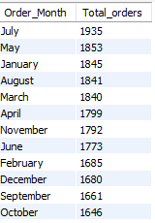

1. **Total sales group by pizza category**

SELECT pizza_category,

SUM(total_price)*100 / (SELECT SUM(total_price) FROM pizza_sales) AS Total_sales

FROM pizza_sales

GROUP BY pizza_category

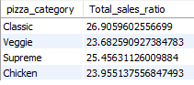

1. **Total sales group by pizza size**

SELECT pizza_size,

SUM(total_price)*100 / (SELECT SUM(total_price) FROM pizza_sales) AS Total_sales_ratio

FROM pizza_sales

GROUP BY pizza_size

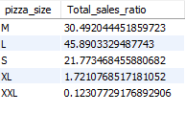

1. **Names of Top 5 bestsellers based on revenue**

SELECT pizza_name, SUM(total_price) AS Total_revenue FROM pizza_sales

GROUP BY pizza_name

ORDER BY Total_revenue DESC

LIMIT 5

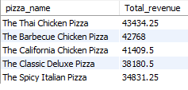

1. **Names of Top 5 bestsellers based on quantity of pizzas sold**

SELECT pizza_name, SUM(quantity) AS quantity FROM pizza_sales

GROUP BY pizza_name

ORDER BY Total_revenue DESC

LIMIT 5  
